562M
JERZEES
8 oz Crewneck
Sweatshirt

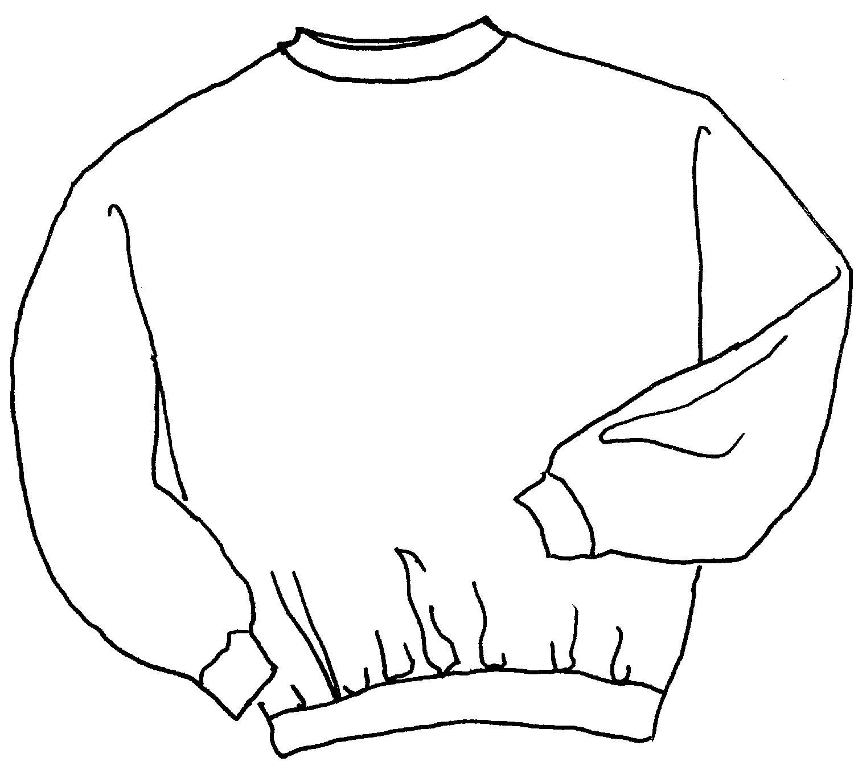

Descriptions
*50/50 poly cotton NuBlend fleece, 8 ounce fleece
*Coverseamed neck and armholes
*Set in sleeves
*Ribbed Spandex in cuffs, collar & waistband
*Embroidery & screenprinting okay

Finished Garment Measurements

Size | S | M | L | XL | 2XL | 3XL | 4XL
Width | 20 | 22 | 24 | 26 | 28 | 30 | 32
Length | 26 | 27 | 28 | 29 | 30 | 31 | 32
Sleeve Length | 35 | 36 | 37 | 38 | 39 | 40 | 41

